Student’s name | …………………………………………………….…… | Grade | 4
Subject | Computer | Quiz No. | 1
Quiz No. ( 1 )
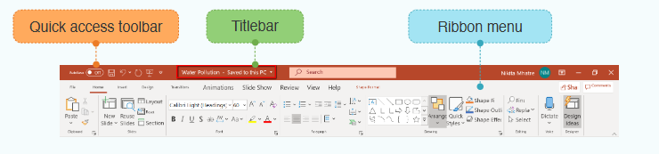
Question A: Write the correct name of each part.
......................................
.......................
......................................
Quick access toolbar | Titlebar | Ribbon Menu

Question B: Write the correct name of each part.
Google Slides | Vector | Canva


Good Luck
Good Luck

